Power BI Healthcare Analytic Dashboard | Hospital - Clinics Report. Create a Report in Power BI.
https://www.youtube.com/watch?v=U5ZKjZsZX64
Our other courses are here: https://pfieuz-schruagh-hydroiaff.yol... If you need me to create your Dashboard send WhatsApp Message to: +234 810 6090 365 Business only.
Download the dataset here: https://drive.google.com/file/d/1h7SH...
https://drive.google.com/file/d/1h7SHRhKeP9jP1axeYRtKg-TE3UldhiYx/view
1. Average Wait Time: Discover how long patients typically wait before their appointments. Uncover patterns and trends that shed light on the efficiency of our healthcare system.
2. Patient Satisfaction: We'll explore the average satisfaction scores given by our patients. Learn about the factors that contribute to a positive patient experience and how we can enhance it.
3. Total Patient Visits Monthly: Get an overview of the ebb and flow of patients through our doors each month. Understand the dynamics of healthcare demand over time.
4. Administrative vs. Non-Administrative Appointments: Delve into the data to distinguish between appointments that involve administrative processes and those that don't. Explore the impact on wait times and patient satisfaction.
5. Referrals and Walk-In Patients: Uncover the balance between patients referred to specific departments and those who walk in without prior referral. How does this impact the overall patient experience?
6. Patient Visits by Age Group and Race: Explore the distribution of patient visits across different age groups and races. Gain insights into the diversity of healthcare needs and preferences.
Join us in decoding the patterns, trends, and valuable insights hidden within this healthcare dataset. Whether you're a healthcare enthusiast, data analyst, or just curious about the inner workings of medical facilities, this video is for you!
Don't miss out on the opportunity to deepen your understanding of healthcare dynamics. Hit the subscribe button, like, and share to stay informed on the latest data-driven content.
Let's navigate the healthcare landscape together! #HealthcareInsights #DataAnalysis #PatientExperience #HealthcareTrends
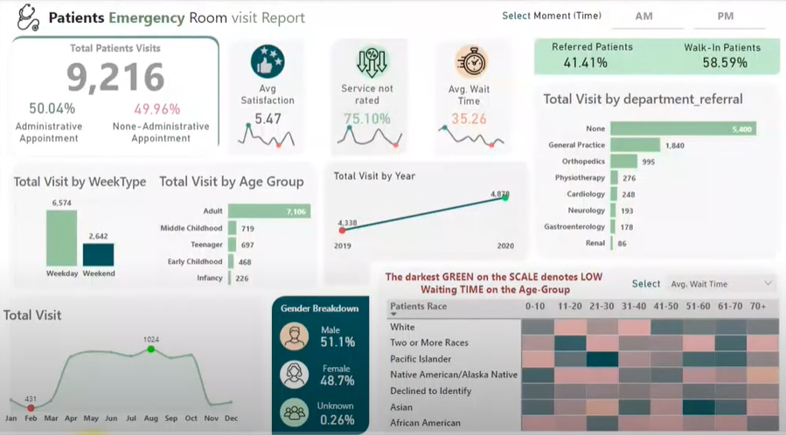
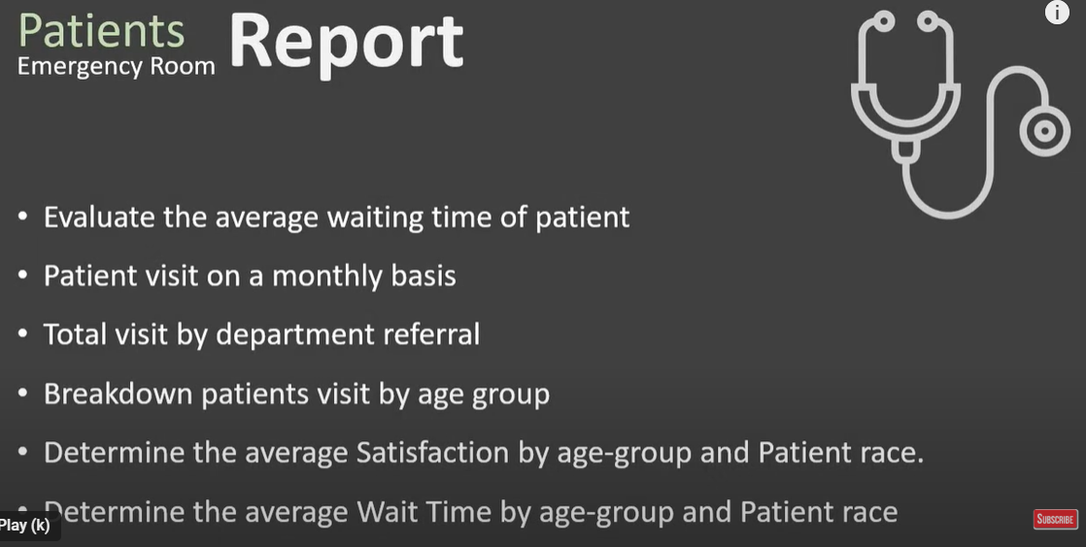

https://www.koenig-solutions.com/upcoming-webinars
Learn Leadership Skills for Emerging Managers
Presenter :- Prerna Talwar
Duration: 1 Hour
23 Feb 2024 at 03:00 PM IST
Register Now !

